Answers to 2010 JJC H2 9647 Chemistry Prelim P2

1. | (a) | quinic acid: Secondary alcohol and tertiary alcohol  maleic acid: alkene  pyruvic acid: ketone  oxalacetic acid: ketone  lactic acid: secondary alcohol | [1m]
 | (b) | pyruvic acid and lactic acid. [1m]  These two compounds have a relatively smaller M_{r} and less extensive hydrogen bonding/weaker intermolecular forces between their respective molecules than the other 3 compounds. [1m] | [1m]  [1m]
 | (c) | Brady’s reagent or 2,4-DNPH | [1m]
 |  | Pyruvic acid will give an orange ppt. but lactic acid will not. | [1m]
 | OR | acidified KMnO₄(aq) or K₂Cr₂O₇(aq)
 |  | Lactic acid will turn purple KMnO₄ colourless but pyruvic acid will not.
 | (d) | Step 1: Prepare aqueous solutions of each of the 3 solid samples by dissolving  1 cm depth of solid in about 5 cm depth of deionised water. | [5m]
Step 2: To 1 cm depth of each of the 3 samples in separate test-tubes, add equal volume of Brady’s reagent.
Oxalacetic acid will give an orange ppt. while the other 2 samples will not.
Step 3: To 1 cm depth of each of the 2 remaining samples in separate test-tubes, add a few drops of Br₂(aq).
Maleic acid will decolourise brown Br₂ while the other will not.
 |  | Step 4: To 1 cm depth of the last sample in a test-tube, add a few drops of acidified KMnO₄(aq). Heat the mixture in a hot water-bath. Quinic acid will turn purple KMnO₄ colourless.
 | (e) | To ensure colour change of KMnO₄, the acidified KMnO₄(aq) must be added slowly and dropwise. It should not be added in excess. The mixture must also be heated.  OR Hydrochloric acid cannot be used to hydrolyse the ester or to acidify KMnO₄ as the chloride ions can be oxidised by KMnO₄. As a result, there may be a colour change of KMnO₄ due to oxidation of chloride to Cl₂. | [1m]
 | (f) | Use a hot water bath for heating instead of using a naked flame directly from bunsen burner as some organic compounds are highly flammable.  or  Use a test-tube holder and dropper when adding chemicals to avoid direct contact with chemicals as chemicals may be toxic/poisonous/ harmful/corrosive | [1m]

2. | (a) | NaOH is completely reacted away. |  |  |  |  | [1m]
 | (b) | (i) For experiment 1 :  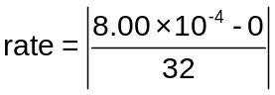 = 2.50 x 10^{–5} mol dm⁻³ s⁻¹  For experiment 2 :  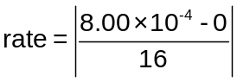 = 5.00 x 10^{–5} mol dm⁻³ s⁻¹  For experiment 3 :  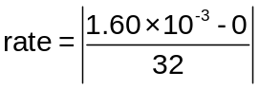 = 5.00 x 10^{–5} mol dm⁻³ s⁻¹ |  |  |  |  | [1m]  [1m]  [1m]
 |  | (ii) |  | Comparing Expt 1 and 2, when [2-bromo-2-methylpropane] is doubled, the rate of reaction is doubled.  Thus, order of reaction w.r.t. 2-bromo-2-methylpropane = 1.  Comparing Expt 2 and 3, when [NaOH] is doubled, the rate of reaction remained constant / unchanged. Thus, order of reaction w.r.t. NaOH = 0. ecf from (b)(ii) |  |  | [2m]
 |  |  | (iii) |  | Rate = k[2-bromo-2-methylpropane]  Units : s⁻¹ |  |  | [1m]  [1m]
 |  |  | (iv) |  | 4 s |  |  | [1m]
 | (c) |  | There are three bulky alkyl groups in 2-bromo-2-methylpropane. Thus 2-bromo-2-methylpropane experiences steric hindrance, which makes it difficult for OH⁻ ion to attack the electron deficient C of C−Br bond. |  |  |  |  | [1m]
[2−methylpropan−2−ol] / mol dm⁻³  0 t Time | (d) |  |  |  |  |  |  | [2m]

3. | (a) | Cathode : 2H₂O + 2e– → H₂ + 2OH–  Anode : 2Br – → Br₂ + 2e– |  | [1m]  [1m]
 | (b) | (i) | S₂O₃^{2–} + 4Br₂ + 5H₂O → 2SO₄ ^{2–} + 10H⁺ + 8Br – | [1m]
 |  | (ii) | Amount of S₂O₃^{2–} = 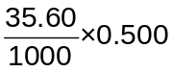 = 0.0178 mol | [1m]
 |  | (iii) | S₂O₃^{2–}  4Br₂  8e–  Amount of e– = 0.0178 x 8 = 0.142 mol | [1m]
 | (c) | Cr^{n+} + ne– → Cr(s)  Amount of chromium = 3.68 / 52.0 = 0.0708 mol  Cr : e–  0.0708 : 0.142  1 : 2 ∴ n = 2 |  | [2m]
 | (d) | (i) | Transition element is a d-block element that forms one or more stable ions with incompletely filled d orbitals. [1m] | [1m]
 |  | (ii) | Chromium show variable oxidation states in their compounds because a variable number of electrons from 3d and 4s orbitals can be used in bonding as the 3d and 4s electrons have similar energies. | [1m]
 |  | (iii) | Cr³⁺ + e–  Cr²⁺ E^{ө} = –0.41V  O₂ + 2H₂O + 4e–  4OH– E^{ө} = +0.40 V  E^{ө}_{cell} = +0.40 – (–0.41) = +0.81 V (energetically feasible) [1m]  4Cr²⁺(aq) + O₂(g)+ 2H₂O(l) → 4Cr³⁺(aq)+ 4OH–(aq) [1m]  Hence chromium(II) sulfate is unstable and rapidly oxidises to green Cr³⁺ in air.
 |  | (iv) | F₂ + 2e–  2F– E^{θ} = + 2.87 V  Cl₂ + 2e–  2Cl– E^{θ} = + 1.36 V  I₂ + 2e–  2I– E^{θ} = + 0.54 V  E(X₂/X–) becomes less positive from F₂ to Cl₂ to I₂ (or down Group VII).  Oxidising power of halogens decreases down Group VII  Hence, F₂ can oxidise Cr to the higher oxidation state of +4,  while I₂ can only oxidise Cr to an oxidation state of +2 in CrI₂. | [3m]
\

4. | (a) | (i) | BaCO₃ (s) → BaO (s) + CO₂ (g) |  |  | [1m]
 |  | (ii) | 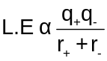  Both CO₃²⁻ and O²⁻ anions are doubly charged.  But CO₃²⁻ has a larger ionic radius/size than O²⁻ anion.  Thus, magnitude of the lattice energy of BaCO₃ is smaller than that of BaO. [2m]
 | (b) | Amt of MgCO₃ = Amt of BaCO₃ 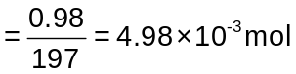  Mass of MgCO₃ = 4.98 x 10^{–3} x 84.3 = 0.42 g not reqd |  |  | [1m] ans in 2dp
 | (c) | (i) | MgCO₃ is the least thermally stable. |  |  | [1m]
 |  | (ii) | The gradient of the graph for MgCO₃ is the steepest. |  |  | [1m]
 | (d) | With its small size and high charge, Al³⁺ cation has a high charge density.  Thus, Al³⁺ is able to polarise the electron cloud of the large carbonate anion (or CO₃²⁻) to such a large extent such that Al₂(CO₃)₃ decomposes readily to give Al₂O₃ and CO₂. |  |  |  | [2m]
 | (e) | (i) | - The volume of gas molecules is negligible as compared to the volume of the container. [1m]  - The gas molecules exert no forces of attraction on one another. |  |  | [1m]  [1m]
 |  | (ii) | No.  At high pressures, the gas occupies a smaller volume. The actual volume of the gas molecules becomes significant and is no longer negligible compared to the volume of the container.  In addition, the gas molecules are close enough for intermolecular forces of attraction to operate between them. |  |  | [2m]
 | (f) | (i)  T₂ > T₁  E_{a}: Activation energy  Molecular Energy  Fraction of particles  E_{a}  T₁  T₂  No. of particles with energy ≥ or > E_{a} at T₂  No. of particles with energy ≥ or > E_{a} at T₁  0 |  | CaCO₃ + 2CH₃COOH → Ca(CH₃COO)₂ + CO₂ + H₂O |  | [1m]
 |  | (ii) |  | At the higher temperature, T₂, the number of molecules with energy greater than the activation energy, E_{a}, increases.  Therefore, frequency of effective collisions between molecules with energy greater than the activation energy increases and results in an increase in rate of reaction. |  | [3m]
 |  | (iii) |  | ClCH₂COOH is a stronger acid. The electron withdrawing Cl atom disperses the negative charge on the ClCH₂COO⁻ anion thus stabilising ClCH₂COO⁻. [1m]

5. | (a) |  |  |  | [2m]
  W :  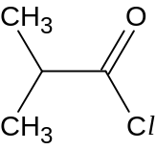 | X :  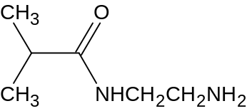
 | (b) | (i) | Acid-base reaction | [1m]
 |  | (ii) | NaOH is added to compound Y to generate a stronger nucleophile for the nucleophilic substitution in reaction II. | [1m]
 |  | (iii) |  | [3m]
  G :  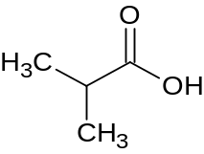 | H :  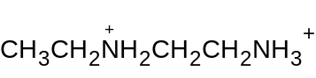

6. | (a) | (i) | 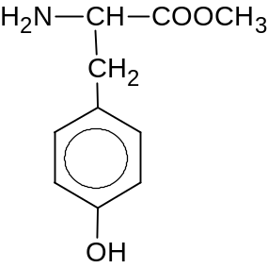 | (ii) | 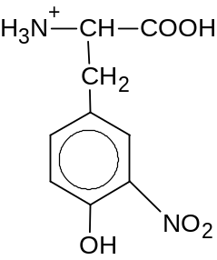 | [2m]
 | (b) | (i) | 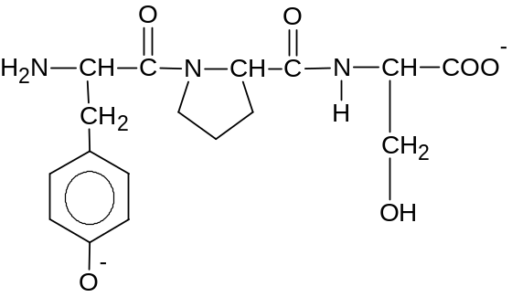  [2m]
 |  | (ii) | 6 |  |  | [1m]
 | (c) | (i) | 6 |  |  | [1m]
 |  | (ii) | M_{r} = 3(181) + 2(115) + 2(105) − 6(18) = 875 |  |  | [1m]
 | (d) | (i) | Heavy metal ion, Hg²⁺, will form ionic interactions with −COO⁻ group in the enzyme. This disrupts the ionic interactions in the tertiary structure of the enzyme.  Heavy metal ion, Hg²⁺, will bond tightly to sulphur / –SH group in the enzyme. This disrupts the disulfide bridges in the tertiary structure of the enzyme.  As a result, the shape of the active site of the enzyme is altered and thus catalytic activity of enzyme is inhibited.  [2m]
 |  | (ii) | Metyrosine competes with tyrosine for the active site of enzyme. |  |  | [1m]

